Notes on agenda items added in dark yellow.

- Clarify consortium marketing goals/intentions
  - What are our priorities?
    - Short term (by Pika launch - live sometime in April)
      - Marketing plan regarding materials quarantine
      - Rebranding (fonts/logo/color)
      - Boilerplate items that libraries can stick their own logos on
      - Education around Pika for patrons, staff, and non-users
      - Push to increase catalog usage
    - Long term (and Beyond!)
  - What do we need to know to focus our efforts?
    - What are we branding? Catalog and …
    - How do our patrons understand our consortium?
    - What is our audience or target population?
    - How do we reflect diversity, equality, inclusiveness?
    - What motivates the people we are trying to attract to use our libraries' resources?
  - Conversation on gathering info
    - Survey
      - on catalog (like survey on WVLS catalog)
      - Many of us have survey fatigue
      - We could use Sierra/Shoutbomb contacts for survey
      - How do we reach non-users?
      - Social media
      - Incentive/prize for participation
      - General questions: what do you like about your favorite apps/other search tools
    - Use small projects as tools to gather data/serve as trial run for initiatives. Ideas include:
      - System read
      - reading challenges
      - photo contest
      - Quarantine campaign

- Consortium Rename/Rebrand
  - New ideas since last meeting:
    - FIND catalog (Chris Seaton)
    - UPLIFT catalog (Chris Seaton)
    - CONNECT catalog (Chris Seaton)
    - Any other brainwaves since we last met
      - Unite/Unity; Empower - we like these words, but they have a certain political tang.
      - Opportunity
      - Spark
      - Sherlock
      - North Star/Polaris: star, “Find your way”, compass, water - might be tricky to use imagery so associated with certain religious traditions
      - Northern Lights/Aurora
      - Inspire/Wonder
      - Ojibwe/Bilingual options: signify our location on traditional lands, reinforces inclusivity; could be perceived as extractive or surface-level gimmick.

  - “Discover” logo/tag ideas
    - Voyageur; “Paddle Rivers of Knowledge and Adventure” (Kristine Lendved)
    - Discover Your Library
    - Discover @ Your Library“The world is at your fingertips. Discover it at your local library.”
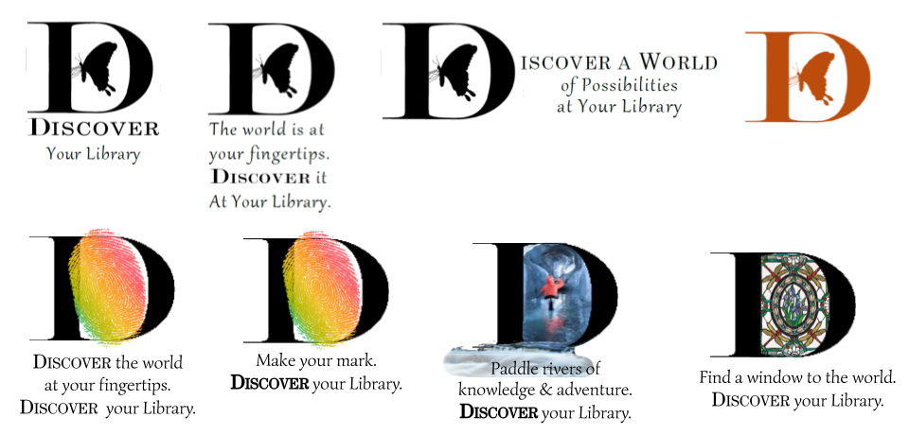
    - Logo concepts
- Action items
  - Designate coordinator for next meeting - Sarah Adams
  - Other?
    - Materials Quarantine Marketing Plan: Darrell and Angie
    - Everyone please come up with at least one
      - brand name/logo concept (in whatever form or media is conducive) and upload to
      - System-wide program idea (ex:Hot Reads for Cold Nights, Photo Contest, etc.) and upload to shared spreadsheet:

