NWLS/IFLS/WVLS (Libraries WIN) System Shared Kits and Equipment
www.Lend-Items.appspot.com

The Item Types of Kits-NWLS, Kits-IFLS and Kits-WVLS are available to any library in the NWLS, IFLS & WVLS areas for booking.

The majority of these kits are sent on the courier route only (few items are pickup only due to their size or fragility). Libraries not on the courier route may still use these kits, but they must either pick the kits up at the loaning site or plan with a site on the courier route for pickup, and notify NWLS, IFLS or WVLS as to where items are to be sent. This info will be entered on your account.

Kits can only be booked by Lend-Items.appspot.com users that have been invited to join the Libraries WIN account on Lend-Items.appspot.com. Lend-Items will not allow NWLS, IFLS or WVLS to book items for your library.

To join:
Please send a request to helpdesk@northernwaters.org asking for a user account in Lend-Items for Libraries WIN. Include:
- Name
- Library
- Phone number
- Email account that you will be using for Authentication.

Lend-Items uses an OpenID Connect authentication system going thru Google, Yahoo or Facebook. The email address you give MUST have an account with one of these websites.

After an account has been created for you, you will receive an email from Lend-Items asking for you to confirm this account. Ex.:

“You have been invited to become a member of Libraries WIN, a library owned by Joshua Klingbeil.
But first we need to complete your registration. Please verify that you received this email by clicking this link:
http://lend-items.appspot.com/conf......
If the link above doesn't work for you, try copying and pasting the entire link into your browser.
After clicking on this link you will be asked to login using your preferred OpenID provider, such as Gmail, Yahoo, AOL, Facebook or Twitter. The advantage of using a third party authentication provider like this is that you will not need a separate password for Lend-Items. Instead, Lend-Items will use your preferred authentication provider each time to log you into the system.
Note. The email address and name used by Lend-Items will be automatically updated to that used by your authentication provider account.
Once you have registered, you will be able to log in using your authentication provider’s account to Joshua Klingbeil's library to view your borrowings, search for items and reserve them. We hope you enjoy using the system.”
To Login:
In this email there will be a link to confirm your account. Click on this link. You will be asked to login. You may login using one of three ways: by your Google account ; your Yahoo account ; or your Facebook account.
Whichever way you decide to use, you must use the email account you received the confirmation. (ie. If you have a personal Facebook account, but the confirmation went to your work email, you must use one of the three accounts that use your work email address.)

When asked for your password (first time only), enter the password from your Google, Yahoo, or FB account.
Bookmark this page: www.lend-items.appspot.com Remember which account you used to authenticate; you will use this account EVERY time you log in to Lend-Items. Using the other methods will not give you access to Libraries WIN items.

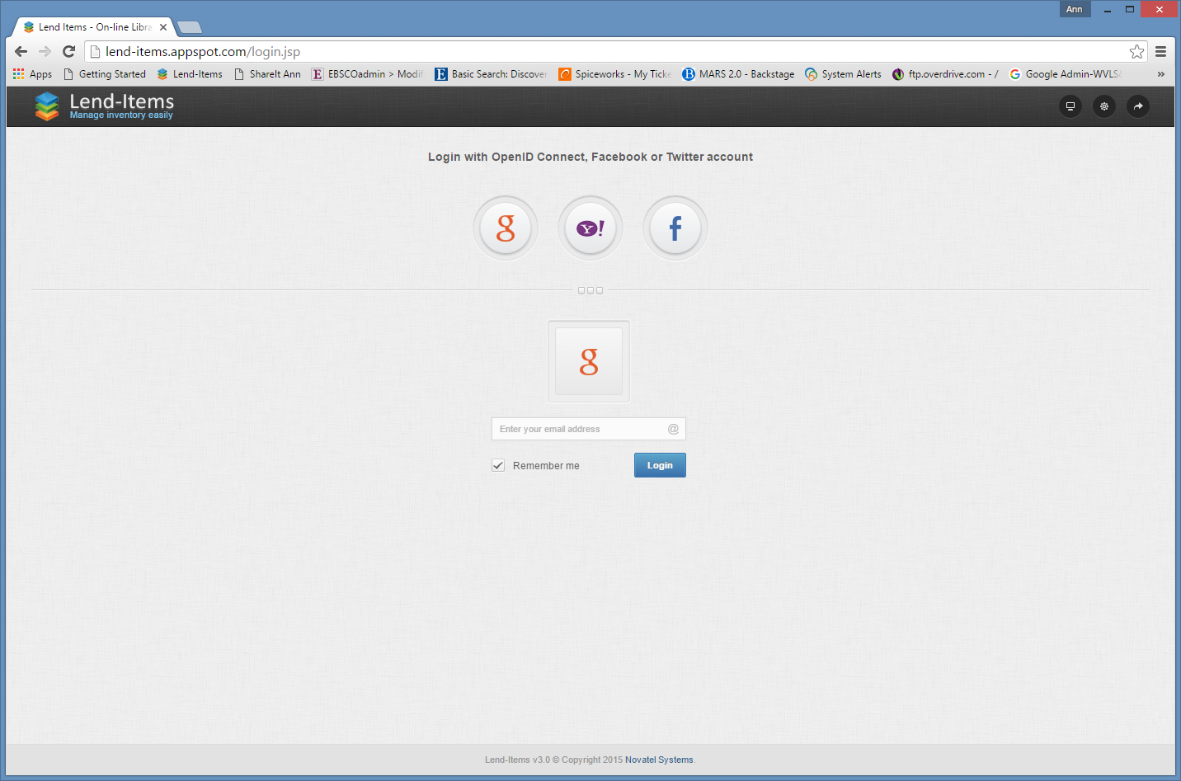

To BOOK a kit:
Once logged in, you will see your user Dashboard (which would list your borrowed items and your bookings).
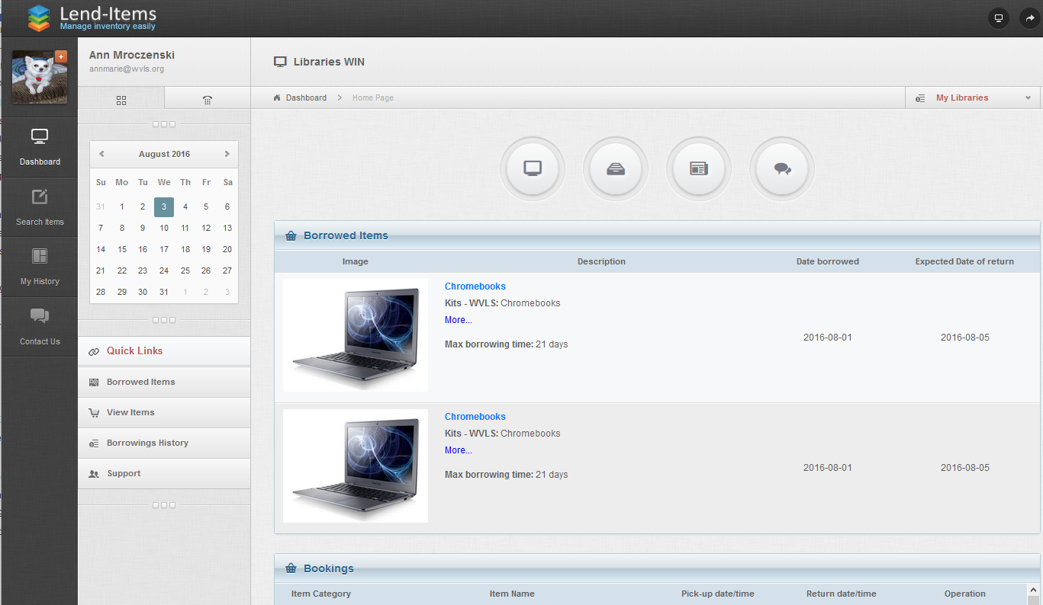

To book items, click on the Search Items side menu button or Items Icon in the center.

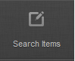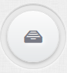

There are currently five different Items Types to choose from when you click the arrow down in the Search Items menu.
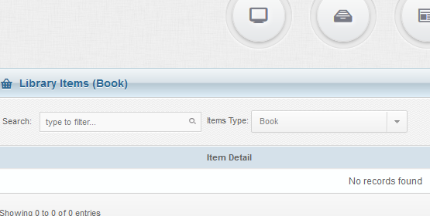

Book – which is a default Item type from Lend Items ; there are no holdings listed in this category.
Kits-NWLS – lists all memory kits owned by NWLS
Kits-IFLS - lists all makerspace kits owned by IFLS
Kits-WVLS - lists all makerspace kits owned by WVLS
All - will bring up all items in Libraries WIN.

Click on the arrow next to the Items Type, make your selection and the list will appear.
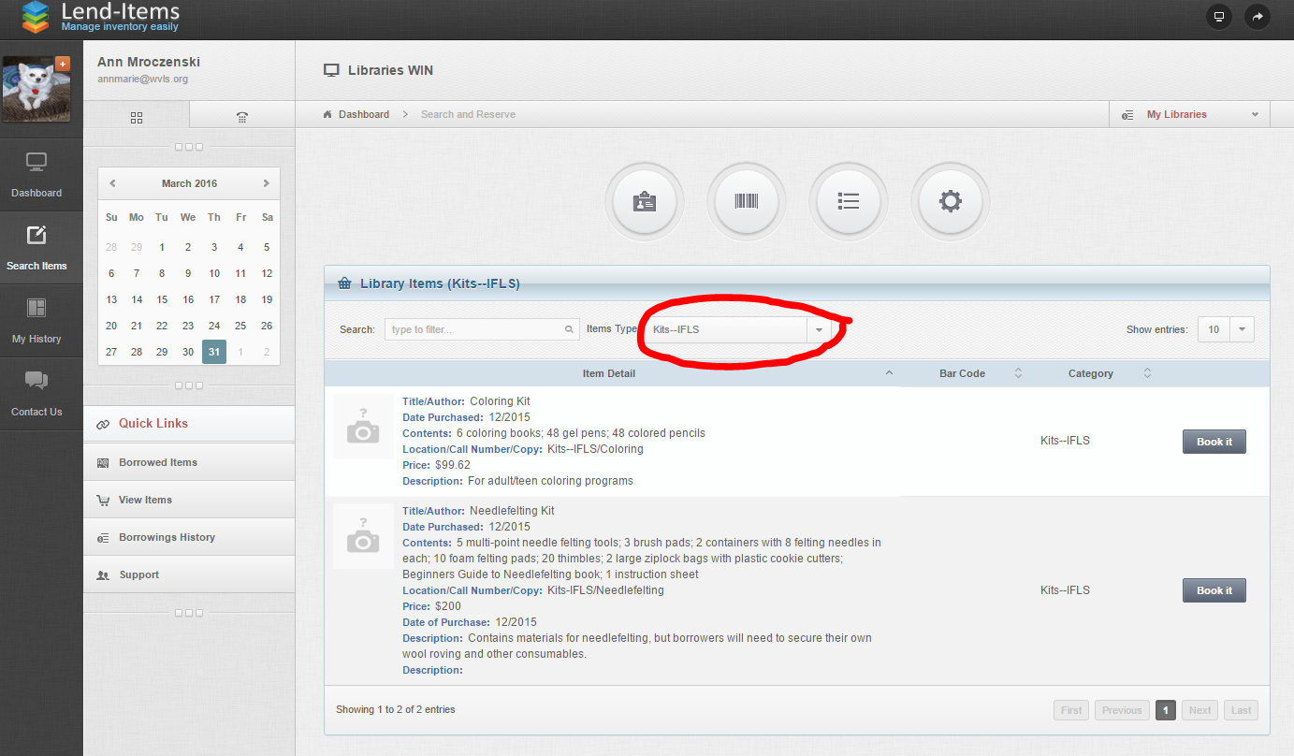

To see if an item is available for specific dates and to reserve an item, click on the Book it button.
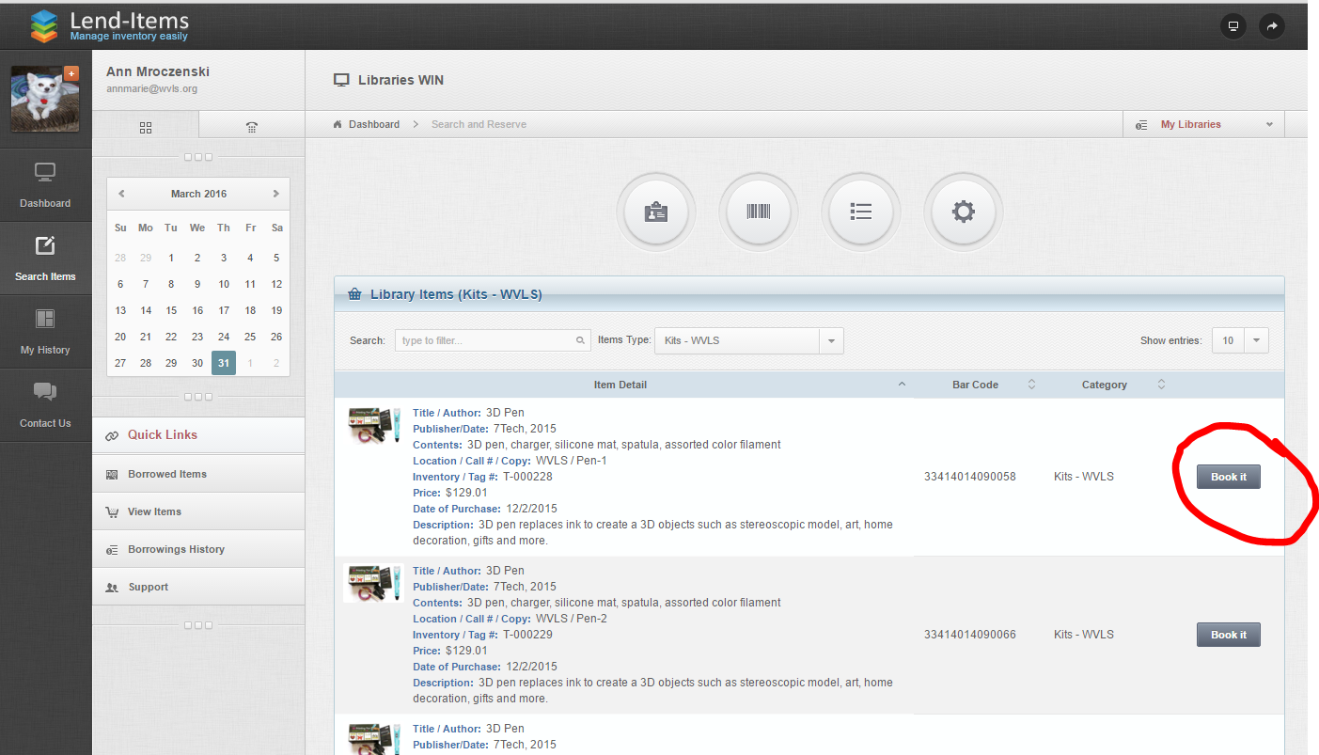

The item details will pop up with a calendar. Click once on the starting day, and click once on the return day. The days in between will be selected.
A few things to keep in mind when booking:
*The calendar is from MONDAY to SUNDAY. Not the usual Sunday to Saturday.
*Lend-Items doesn’t block weekends or holidays from booking / returning, and the NWLS / IFLS / WVLS offices will only ship on days open.
*There are a few items that do not ship. This will be listed in the item details Note field.
*REMEMBER that the starting day is the pickup/shipping day and the return day is the day it will be back in the NWLS/IFLS/WVLS office. Usually it takes TWO days to send and TWO days to return. A maximum of 21 days for total booking, however, you may request a renewal from NWLS/IFLS/WVLS if no one else has the item booked. If you need an item longer, contact NWLS, IFLS or WVLS for special booking.
*Plan ahead. If you book an item the same day it needs to ship, you may not get it in time.
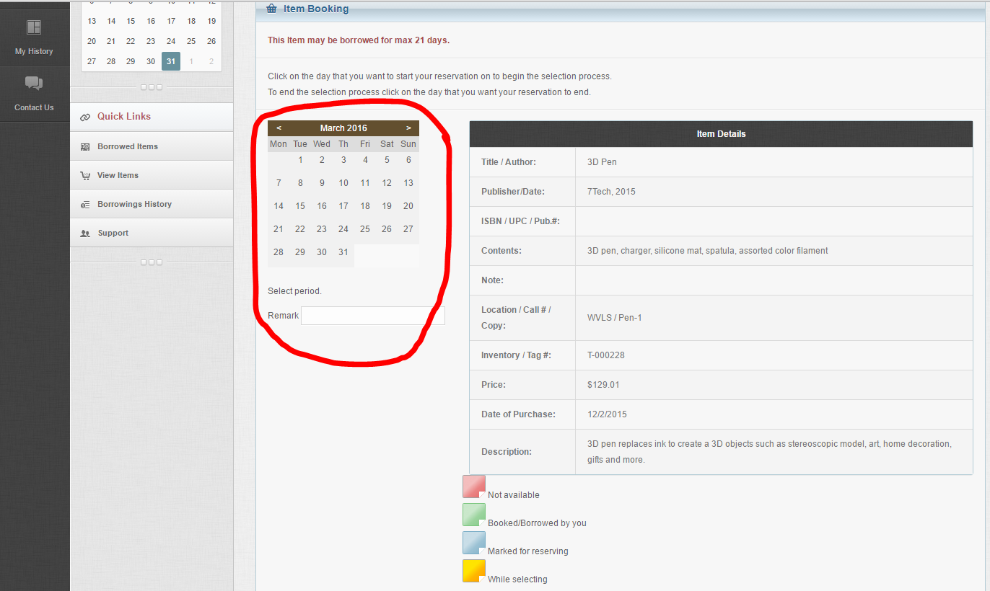

If you want to pick up the items, PLEASE add this to the Remark space.

After you have selected the first and last day, scroll to the bottom of the page and click ‘Book it’ to confirm your booking.
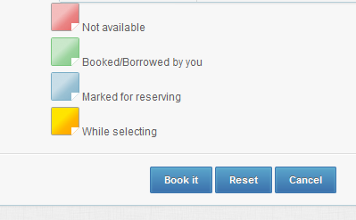
If done correctly you will be routed to a Reservation page confirming your reservation. Scroll down and click OK.
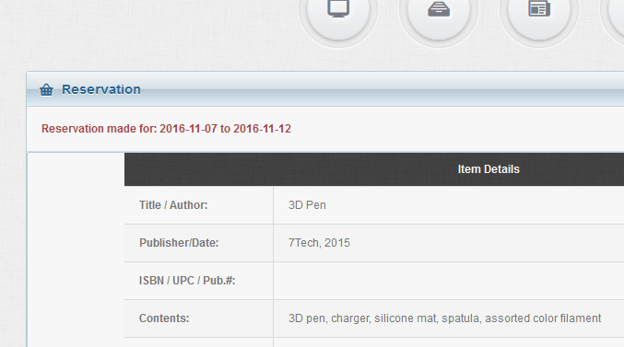

This booking will also be on your Dashboard, under the Bookings section, with the option to cancel.
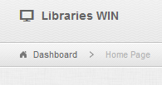
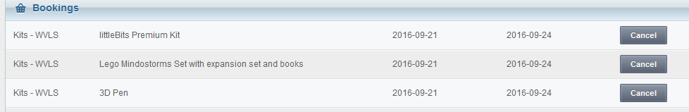

You will also receive an email verifying your reservation.
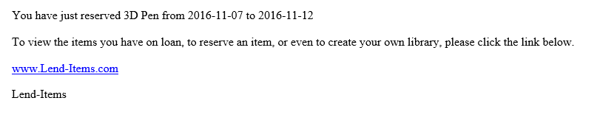

RECEIVING
On the day your item is to be shipped / picked up you will receive an email letting you know that your item was checked out by NWLS/ IFLS / WVLS staff. This email also includes the date it is due back at their office. Please remember to return your items on time, others may be waiting.

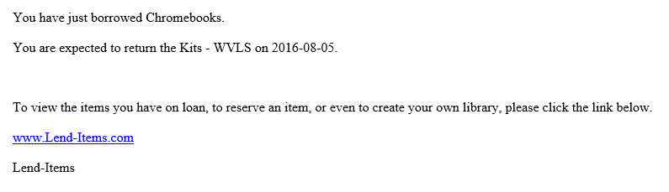
If you do not receive your item within three days, please contact the owning office.

Items sent in locked containers: the lock combination is listed in the Item Details, Note field.

If you receive an item that has been damaged or if an items has been damaged in your care, please contact the owning office promptly.

RETURNING
When returning an item, please make sure all parts and pieces are returned together in the correct containers. Please do not mix multiple kits.
All lids that are not locked should include tape to keep them from popping off.
Some of the makerspace items are packaged precisely for keeping damage during shipping to a minimum. Please return these items as they were shipped to you with the enclosed packing material.

OVERDUES
If NWLS / IFLS / WVLS doesn’t receive the item back on the date due, Lend-Items will send you an overdue notification email.

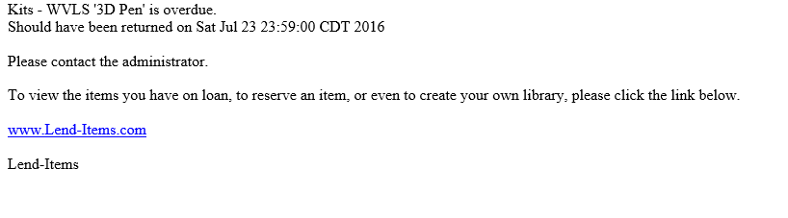
Please return the item promptly. If you cannot return the item promptly, please contact the owning office.

If you have any questions, please feel free to contact the NWLS office for more info.

OTHER INFO
The WVLS website offers several recordings and idea sheets about using the kits and equipment.

